CIE 337 Final report Part I

Hazem Muhammad Tarek 201800283

Moataz Mohamed 201801903

Yara Atef 201801745

**Test case I:**

$$f_{s }=40$$

$$µ=0$$

$$L=8$$

$$m_{p}=0$$

Encoder: unipolar NRZ

**Graphs:**

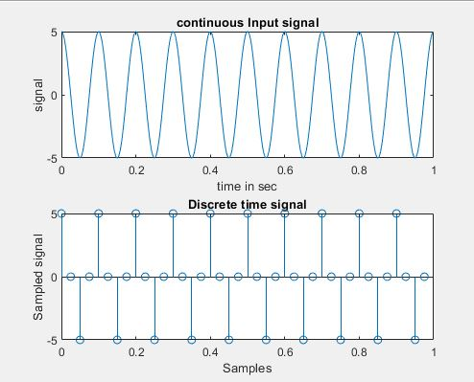

Plot of the continuous input signal and the discrete time signal which is basically the input signal after passing through the sampler.

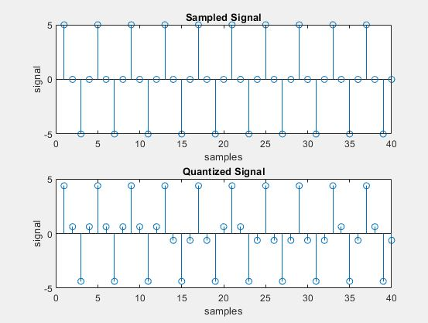

Plot of the sampled signal which is given as an input to the quantizer and the quantized signal quantized by a uniform midrise quantizer based on the number of levels ***L***.

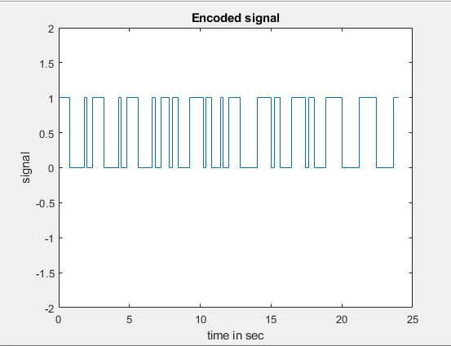

Plot of the quantized signal after getting encoded using the Unipolar NRZ line code with amplitude of coding equals 1.

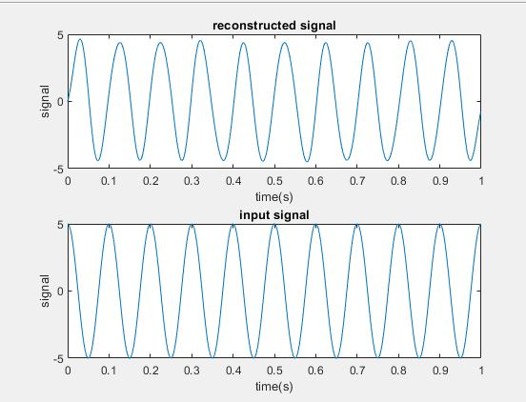

Plot of the continuous time signal and the reconstructed signal which is reconstructed by decoding the encoded signal then passing it through a de-quantizer then passing it through the reconstruction filter which multiplies the dequantized signal by a Sinc function to reconstruct the original signal.

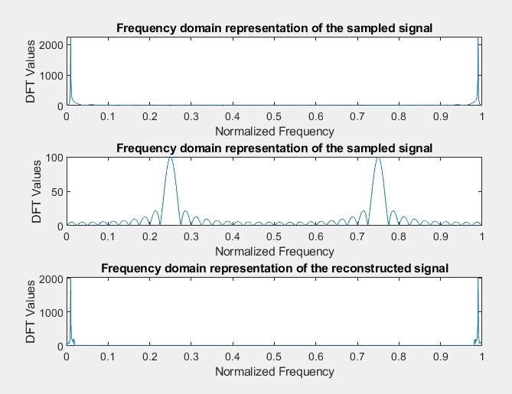

Plot of the frequency content of the input signal, sampled signal, and the reconstructed signal.

**Test case II:**

$$f_{s }=20$$

$$µ=0$$

$$L=32$$

$$m_{p}=5$$

Encoder: polar NRZ

**Graphs:**

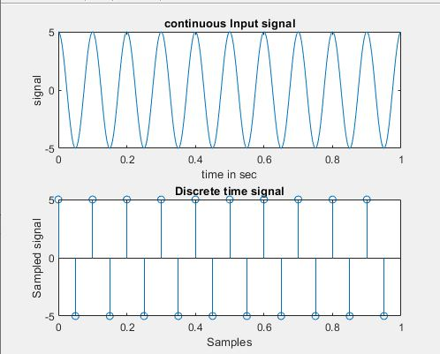

Plot of the continuous input signal and the discrete time signal which is basically the input signal after passing through the sampler.

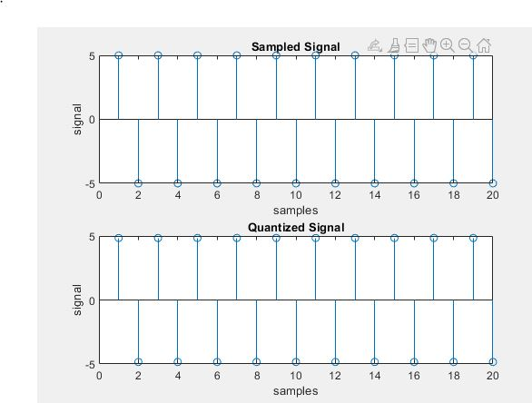

Plot of the sampled signal which is given as an input to the quantizer and the quantized signal quantized by a uniform midrise quantizer based on the number of levels ***L***.

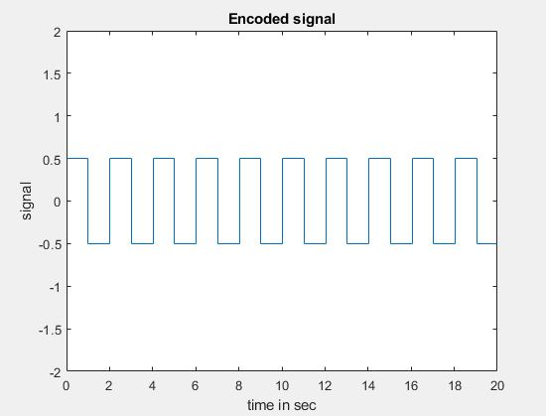

Plot of the quantized signal after getting encoded using the polar NRZ line code with amplitude of coding equals 1.

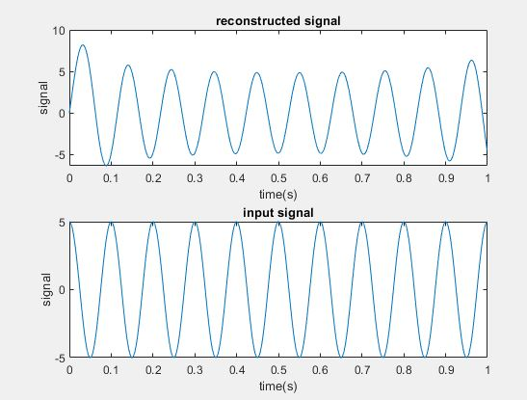

Plot of the continuous time signal and the reconstructed signal which is reconstructed by decoding the encoded signal then passing it through a de-quantizer then passing it through the reconstruction filter which multiplies the dequantized signal by a Sinc function to reconstruct the original signal.

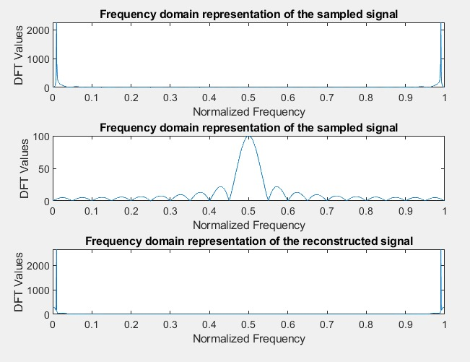

Plot of the frequency content of the input signal, sampled signal, and the reconstructed signal.

**Test case III:**

$$f_{s }=20$$

$$µ=100$$

$$L=32$$

$$m_{p}=5$$

Encoder: Manchester

**Graphs:**

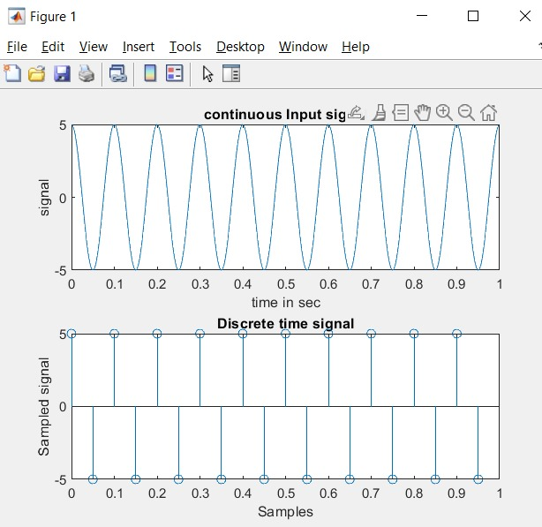

Plot of the continuous input signal and the discrete time signal which is basically the input signal after passing through the sampler.

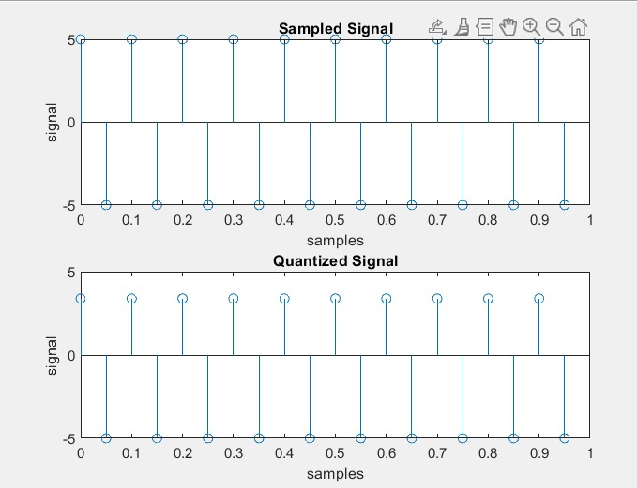

Plot of the sampled signal which is given as an input to the quantizer and the quantized signal quantized by a non-uniform quantizer based on the number of levels ***L***.

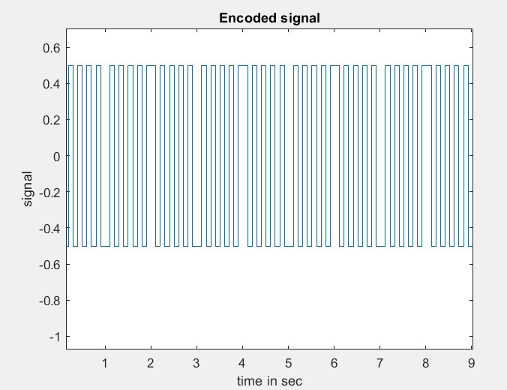

Plot of the quantized signal after getting encoded using the Manchester line code with amplitude of coding equals 1.

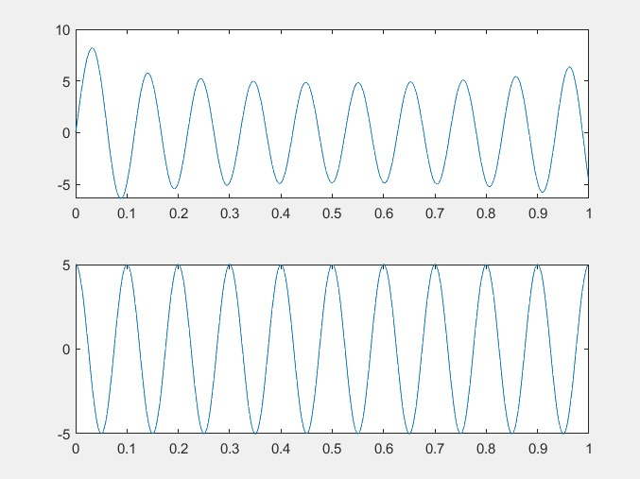

Plot of the continuous time signal and the reconstructed signal which is reconstructed by decoding the encoded signal then passing it through a de-quantizer then passing it through the reconstruction filter which multiplies the dequantized signal by a Sinc function to reconstruct the original signal.

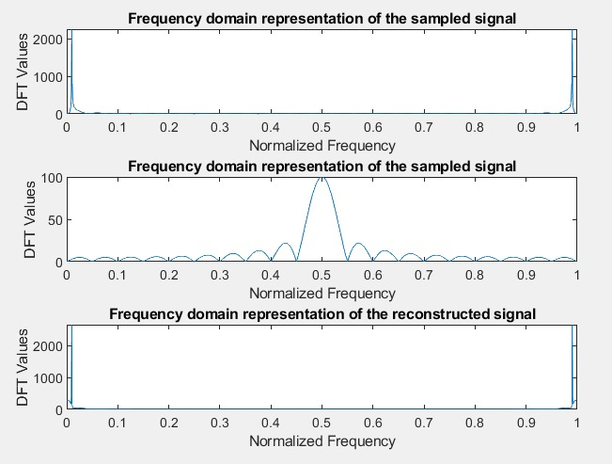

Plot of the frequency content of the input signal, sampled signal, and the reconstructed signal.

**Test case IV:**

$$f_{s }=15$$

$$µ=0$$

$$L=16$$

$$m_{p}=5$$

Encoder: Unipolar NRZ

**Graphs:**

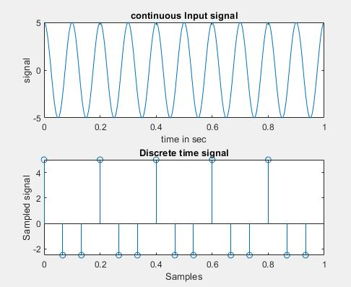

Plot of the continuous input signal and the discrete time signal which is basically the input signal after passing through the sampler.

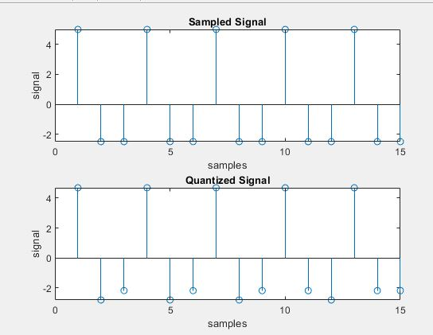

Plot of the sampled signal which is given as an input to the quantizer and the quantized signal quantized by a uniform midrise quantizer based on the number of levels ***L***.



Plot of the quantized signal after getting encoded using the unipolar NRZ line code with amplitude of coding equals 1.

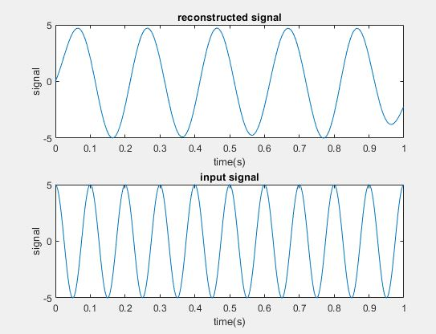

Plot of the continuous time signal and the reconstructed signal which is reconstructed by decoding the encoded signal then passing it through a de-quantizer then passing it through the reconstruction filter which multiplies the dequantized signal by a Sinc function to reconstruct the original signal.

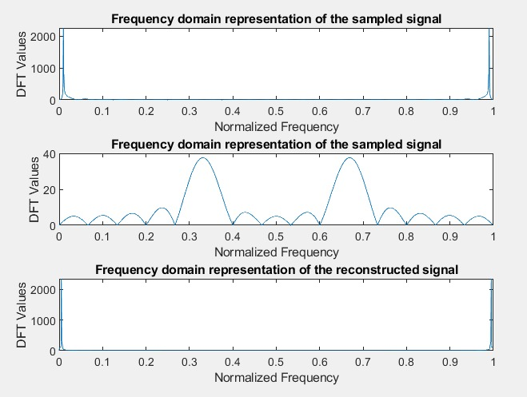

Plot of the frequency content of the input signal, sampled signal, and the reconstructed signal.